**The Social Dilemma**

1. Have you ever planned something and had something go completely unexpected? What happened?
2. How has social media helped society?
3. How has social media hurt society?
4. How many hours a day do you think you spend on social media?
5. How many hours a day do you think you spend on your phone or computer?
6. Why can it be difficult to unplug from the phone or computer?
7. Do you think big tech companies like Facebook, Google or Snapchat should filter content?
8. Why is marketing important for businesses?
9. What is ethical design?
10. What are some ways that social media measures engagement? How is this important for advertisers?

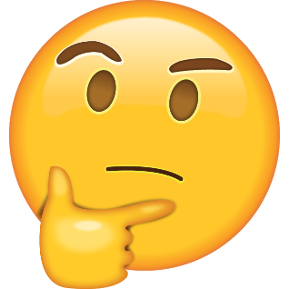

1. What are some ways that social media sites and app keep users addicted and glued to their screens? Why are they effective?
2. One of the creators of the like button stated it was originally intended to spread positivity and the creators never dreamed that teenagers would become insecure about not receiving enough likes. What are your thoughts on the topic?
3. How does social media manipulate people using their own psychology?
4. What are some dangers in using social media for social validation?
5. How does social media incite hatred, rage and false information?
6. Why does false news share faster than real news?
7. 64% of people who joined extremist groups on Facebook did so because of algorithms. On the other hand, extreme censorship can result in banning anyone who might think differently? What are some pros and cons of censorship on a platform like Facebook or Snapchat?
8. Have you ever seen an ad for something you recently Googled or showed interest in? How did it make you feel?
9. What are some pros and cons of algorithms?
10. What are some recommendations to effectively limit your social media usage? How does each recommendation help?